Oracle Homework Chapter 1

This homework assignment is to make sure that you have the demo files, and that you are ready to use Oracle database server and its client tool, SQL Developer.

- Make sure that you have installed Oracle Database Express 11g and SQL Developer.
- Create a folder named Oracle in the top-level directory of your C-drive. Do NOT create it in a sub-folder of C. This folder should have a pathname of C:\Oracle.
- Then in the Oracle folder, create folders called Ch1, Ch2, Ch3, Ch4, … Ch12. These are the folders where we will save future problems and SQL scripts. Name these exactly as specified--not something else.
- Start SQL Developer. Double click myschema under Connections. Fill in your Oracle username and password. It is the same ones you used for Application Express and SQL*Plus.
- You should have already run the script create_schema_11g.sql to create the Human Resources tables: EMPLOYEES, DEPARTMENTS, COUNTRIES, etc.

Verify by selecting expanding Tables and opening the EMPLOYEES table.
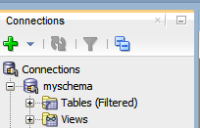
Expand Tables, then double-click EMPLOYEES

Once the table is open, select the Data tab. You should see the following columns and data for EMPLOYEES:
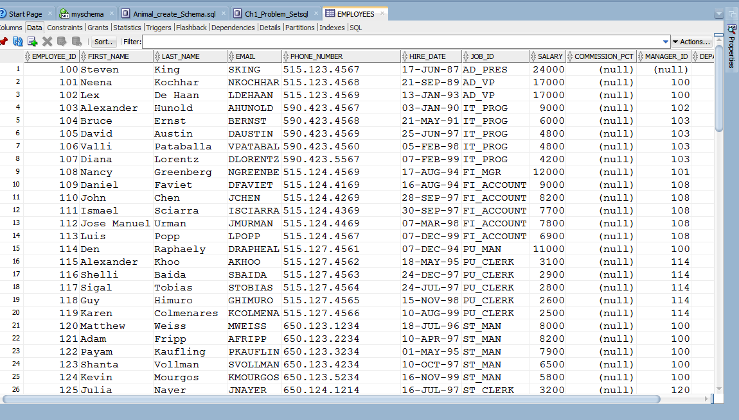
- You should have also run the second script that will create the other demo tables for this class. This is NORTHWOODS CREATE SCHEMA (zipped) that is saved in START HERE in D2L. If you have not, then download the file Northwoods10g.zip and save it in the folder C:\Oracle. Unzip this file, then open it and run it in SQL Developer.
- This will create the tables:
STUDENT, FACULTY, TERM, LOCATION, GRADE, COURSE, COURSE_SECTION, ENROLLMENT

Verify by opening some of these tables and looking at the Data tab.

- Download and unzip the SQL Script Animal_create_schema.sql. Run it in order to create the Animal Rescue schema. This will create the tables: ANIMAL, BREED, VOLUNTEER, WISHLIST, and ADOPTER. Verify that you have these tables by selecting the data from a few of these tables.
- Now we will write a few simple queries and learn how to turn it in for grading. In this class, we will name all of our problems by the chapter name, then the problem name. So Chapter 1-Problem1 is named ch1p1, and Chapter 1-Problem 2 is named ch1p2. You must follow this convention throughout the course. This is how we have a common way to identify specific problems.

- Click File | New, then expand Database Tier. Select Database Files, and you will see the following dialog box:
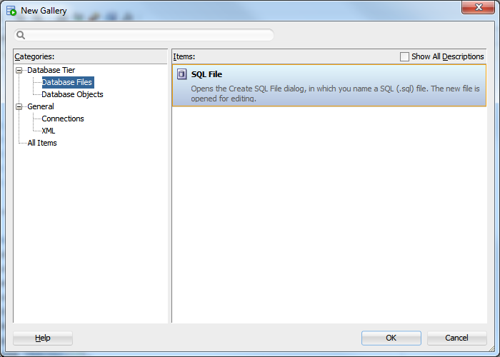
Select SQL File
- For the name of the problem, type ch1_Problem_Set and then select Browse to locate the Ch1 folder. Your screen should look like this:

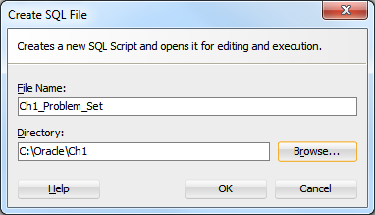

- Type a few comments that include:
-- Your Name
Note:
Two dashes followed by a space is the SQL comment indicator
-- Date

- Type in the following SELECT statement:

-- ch1p1
SELECT department_id,department_name
FROM departments
WHERE location_id <> 1700;

- Click the Green arrow to run. If you are asked to select a connection, select myschema.

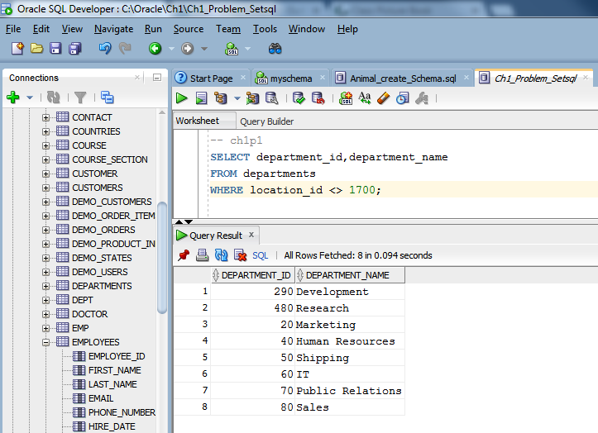
Click the green arrow to run.
Enter this SQL Query. The operator in the WHERE clause is <> which means “not equal to”
(< followed by >)

- Press CTRL + S, or select File | Save or click SAVE on the menu bar.
- Now enter the second query, Ch1p2:

-- ch1p2
SELECT employee_id, last_name, salary
FROM employees
WHERE department_id = 20;

- Save and run ch1p2.
- Write the code for ch1p3 to include the animal’s id, name, age, and weight from the ANIMAL table, such that the animal’s age is less than or equal to 3, and their weight is equal to 6.
- Save and run ch1p3. (You should get just 1 record for the animal named Shadow.)
- Ch1p4: CREATE one query where you select 3 or more columns from one of the tables, and include an appropriate WHERE clause.
- When you have finished the 4 problems, you may exit SQL Developer by selecting File | Exit.
- Submit ch1_Problem_Set to the correct folder in the D2L Dropbox.

